Affordable Communities of Texas
Request for Proposals for Development Partnership

Purpose
The Texas State Affordable Housing Corporation (“Corporation”) is seeking proposals from developers to assist with the redevelopment of a multifamily project site in Plano, Texas. This RFP and all associated agreements will be administered under the Corporation’s Affordable Communities of Texas land banking program (the “ACT”).

Introduction
The Corporation is a 501(c)(3) nonprofit organization that was created at the direction of the Texas Legislature to serve as a self-sustaining, statewide affordable housing provider and was incorporated in 1994.

The Corporation owns approximately 1.5 acres of land near the central business district of Plano, Texas. The site was acquired in 2012 with the intent of redeveloping it for affordable multifamily housing. The Corporation is now seeking development partners that can carry out the planning and redevelopment of the property.

If you have any questions about the ACT program, the information requested in this application, or the project site, please call David Danenfelzer at 512-477-3562 or email your questions to ACTinfo@tsahc.org

Eligible Respondents
The Corporation will accept applications from qualified nonprofit, for-profit and local government entities (“Respondents”) that have a history of providing housing services within Texas. Respondents may apply alone or in combination with other development partners that will enhance their ability to complete the proposed development. Minimum qualifications for all Respondents, and each partner listed within the application, include:
- Nonprofit entities must be an active nonprofit 501(c)(3) or (c)(4) corporations as recognized by the U.S. Internal Revenue Service, and registered as a nonprofit corporation within the State of Texas;
- Provide financial audits or statements for a two year period that reflect the entity’s ability to manage funds appropriately;
- Have at least five years of experience in the planning, marketing, development or management of housing programs for moderate and low-income households; and
- No previous defaulted contracts or debarment from the Corporation, the Texas Department of Housing and Community Affairs, or any other local government, state or federal programs.

Application Process
The Corporation will accept responses to this Request for Proposals from the date of its publication through February 10, 2016. Applications must be complete and submitted with all requested due diligence and support documents. Applications must be signed and dated as required in this RFP. All scanned documents must be readable using Adobe PDF Reader software. Finally, applications must be typewritten on the application materials provided by the Corporation, as handwritten applications will not be accepted.

Project Description
The project site is located in Plano, Texas along 14th Street between Avenues F and G. The site is comprised of 1.54 acres with frontage the length of 14th Street. The Corporation purchased the site in 2012 and the site was cleared of all existing structures in 2013. A Phase I Environmental report and survey of the site have been completed, though may need to be updated.
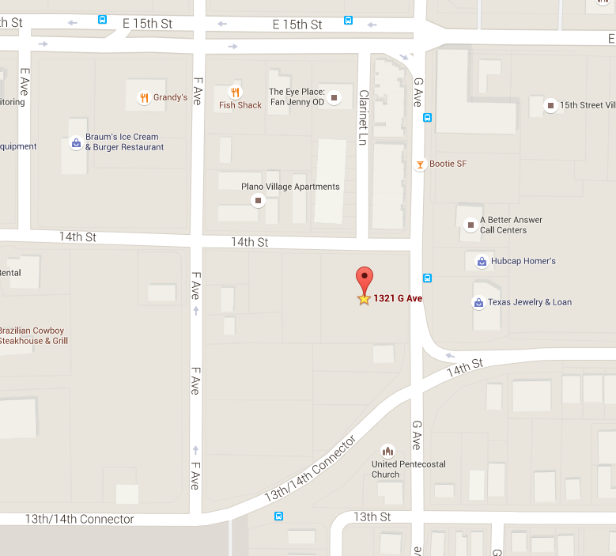

The Respondent selected to complete the redevelopment of the property will be responsible for all planning and zoning activities in order to complete their proposed redevelopment strategy. The Corporation also requires the following affordable requirements from all proposals in order to fulfill our charitable mission.

- Proposals that include the creation of new rental housing must ensure that at least:
  - 20% of all unit types constructed are affordable to households at 50% of the area median income for Plano, Texas; or
  - 40% of all unit types constructed are affordable to households at 60% of the area median income.
- Proposals that include the creation of new for-sale housing must ensure that at least 60% of all housing units are affordable to households at 80% of the area median income.

The Corporation is open to any and all building formats or styles (condominium, townhomes, low-rise, garden style, etc.) that will feasibly provide for affordable housing at the site.

The Corporation will also accept proposals to purchase the property or swap for a site that is determined, at the sole determination of the Corporation, to be better suited and feasible for the development of affordable housing.

The Corporation does intend to recoup its investment in the property through the planned redevelopment. In order to make a proposal feasible the Corporation is open to continued, long-term, involvement in the development in order to assist in lowering total up front development costs and to provide a continued property tax exemption to the property in order to ensure long-term affordability.

Selection
The Corporation will select a Respondent based upon demonstrated competence, experience, and on the reasonableness of the proposed development activities, in the sole determination of the Corporation. All things being equal, the Corporation will give priority to Respondents whose principal place of business is located in Texas and Respondents who are or whose response includes qualified Historically Underutilized Businesses (HUBs) or Minority Owned Businesses (MOBs).

The Corporation reserves the right to negotiate all elements that comprise the Respondent’s submission. The Corporation reserves the right for any reason to reject any and all applications and to re-solicit; the right to select a Respondent for specific purposes or for any combination of specific purposes; and to defer the selection of any Respondent to a time of the Corporation's choosing.

Approvals
After the Corporation’s staff has reviewed all submissions, a meeting of the Executive Vice President, Chief Financial Officer and President shall be held to select a final Respondent. The Corporation may request finalists to make a presentation to staff or the Corporation’s board prior to final approval. The Corporation’s Manager of Development Finance will notify Respondents in writing of the Corporation’s decision. The Corporation reserves the right to not select a Respondent from the applications submitted.

Conflict of Interest
Although the Respondent will work in partnership with the Corporation, and not as an employee or contractor of the Corporation, to avoid all possibility of conflicts of interest all Respondents must certify that none of the owners, officers, or stockholders of the company and none of their families are related within the third degree of consanguinity or the second degree of affinity to any Corporation employee or any member of the Board of Directors.

Cost Incurred to Respond
All costs directly or indirectly related to preparation of a submission or any oral presentation required to supplement and/or clarify a submission which may be required by the Corporation shall be the sole responsibility of and shall be borne by Respondents.

Release of Submissions and Proprietary Information
If a Respondent submits proprietary information that should not be publicly disclosed, the proprietary information must be clearly identified at the time of submission. If a Respondent fails to identify proprietary information, all information in the submission will be deemed non-proprietary and will be made available upon request pursuant to the Public Information Act after the review process has been completed.

Indemnification
All Respondents must agree to indemnify, defend and hold harmless the Corporation and its officers, agents and employees from any and all claims and losses accruing or resulting from the Respondent’s performing professional services for the Corporation.

Federal, State and Local Requirements
Selected Respondents are responsible for both federal and state unemployment insurance coverage and standard workers compensation insurance coverage. Respondents must comply with all federal and state tax laws and withholding requirements. The Corporation will not be liable to a Respondent or its employees for any unemployment or workers' compensation coverage or federal and state tax withholding requirements. Respondents shall indemnify the Corporation and pay to the Corporation any costs, penalties or loss whatsoever occasioned by Respondent's omission or breach of this section.

Respondent Information
Respondents must complete each of the following questions as directed and submit all requested documentation, if any, behind this tab of the application.

Lead Respondent: NAME OF RESPONDENT
Mailing Address: INCLUDE STREET, CITY, STATE AND ZIP
Primary Phone: PRIMARY PHONE | Fax: FAXCIMILE #
Contact Name: CONTACT NAME | Email: MAIL OF CONTACT PERSON
This Partner is a:
Local government | Local HFC | PHA | Nonprofit Entity | For Profit

Second Respondent: NAME OF RESPONDENT
Mailing Address: INCLUDE STREET, CITY, STATE AND ZIP
Primary Phone: PRIMARY PHONE | Fax: FAXCIMILE #
Contact Name: CONTACT NAME | Email: MAIL OF CONTACT PERSON
This Partner is a:
Local government | Local HFC | PHA | Nonprofit Entity | For Profit

Third Respondent: NAME OF RESPONDENT
Mailing Address: INCLUDE STREET, CITY, STATE AND ZIP
Primary Phone: PRIMARY PHONE | Fax: FAXCIMILE #
Contact Name: CONTACT NAME | Email: MAIL OF CONTACT PERSON
This Partner is a:
Local government | Local HFC | PHA | Nonprofit Entity | For Profit

Nonprofit Respondents must submit:
- A copy of the Respondent’s filing status with the Texas Secretary of State stating the entity is a nonprofit entity legally active within the State of Texas, with a list of all current board members; and
- A copy of the Respondent’s 501(c)(3) or 501(c)(4) determination letter from the Internal Revenue Service. The determination letter must have been granted at least 2 years prior to the submission of this application.

Historically Underutilized Businesses
- Respondents that are qualified Historically Underutilized Businesses (HUBs) or Minority Owned Businesses (MOBs) must submit proof of this status. Copies of certificates of qualified status may be available through the Texas Comptroller of Public Accounts.

All Respondents must submit:
- A copy of the Respondent’s filings status with the Texas Secretary of State, a “Certificate of Account Status,” from the Texas Comptroller’s office, and a list of all members of the corporation; and
- Each Respondent must submit copies of their most recent 2 years of audited financial statements. If a Respondent does not have audited financial statements please contact the program manager to discuss alternatives.
- A narrative (1000 words or less) describing the Respondent’s experience in residential construction, property management and affordable housing development. Include specifics about previously completed projects, financing used and affordability requirements. If a Respondent has promotional materials about their experience in affordable housing, please provide.
- At least three references of persons that have direct knowledge of the Respondent’s ability to carry out housing development projects. References may include, past or present funders, banking relationships, development partners, government officials, etc.
- A narrative (1000 words or less) and supporting documents, if any, that describes the Respondent’s proposed redevelopment strategy. The narrative should include estimates on the number of units, affordability set-asides, form of housing (i.e. townhomes, condo, low-rise, garden style) and financing available to complete the project. Respondents are encouraged to draw links between this proposal and past experience with projects of a similar size and structure.

Certifications
Respondents must agree to the listed Certifications and submit an executed copy of this Certifications page at the end of their application.

- Respondent and Respondent’s principal(s) shall be held to all representations made in this application.
- Respondent and Respondent’s principal(s) certify to the best of their knowledge that all previously owned and/or developed affordable housing properties are compliant with all applicable bond, tax credit, HOME, or other federal, state, or local affordable housing program(s) from which the properties received funding.
- Respondent and Respondent’s principal(s) certify that they have read and understand the Corporation’s policies for the Affordable Communities of Texas program and shall adhere to all thresholds, standards and requirements of those policies.
- Respondent and Respondent’s principal(s) understands that this RFP and application does not represent a commitment on behalf of the Corporation to participate, fund or loan financial resources to the Respondent or Respondent’s principal(s). Rather, this RFP and application are an indication that the Corporation will review and consider the proposed activities in accordance with the Corporation’s policies and subject to the Respondent’s (1) readiness to proceed, (2) compliance with the Corporation’s policies, and (3) cooperation in providing any and all requested information to the Corporation.
- Respondent and Respondent’s principal(s) certify that they understand that any preliminary official action of the Corporation, commitment, or award by the Corporation may be terminated by the Corporation by written notice at any time.
- Respondent and Respondent’s principal(s) certify that they will be responsible for retaining all records associated with the redevelopment of the property in relation to, or as a result of this, and that all such records shall be available to the Corporation, its Auditors and any Federal or State entity requesting to review all retained documents.
- Respondent and Respondent’s principal(s) certify that that development, construction, operation and provision of affordable housing is part of the Respondent’s mission and purpose, and that the signature below was provided by a person authorized by the Respondent and Respondent’s principal(s) to sign and submit this application.

By: (print name of authorized representative) | Signature: | Date:

By: (print name of authorized representative) | Signature: | Date:

By: (print name of authorized representative) | Signature: | Date:

