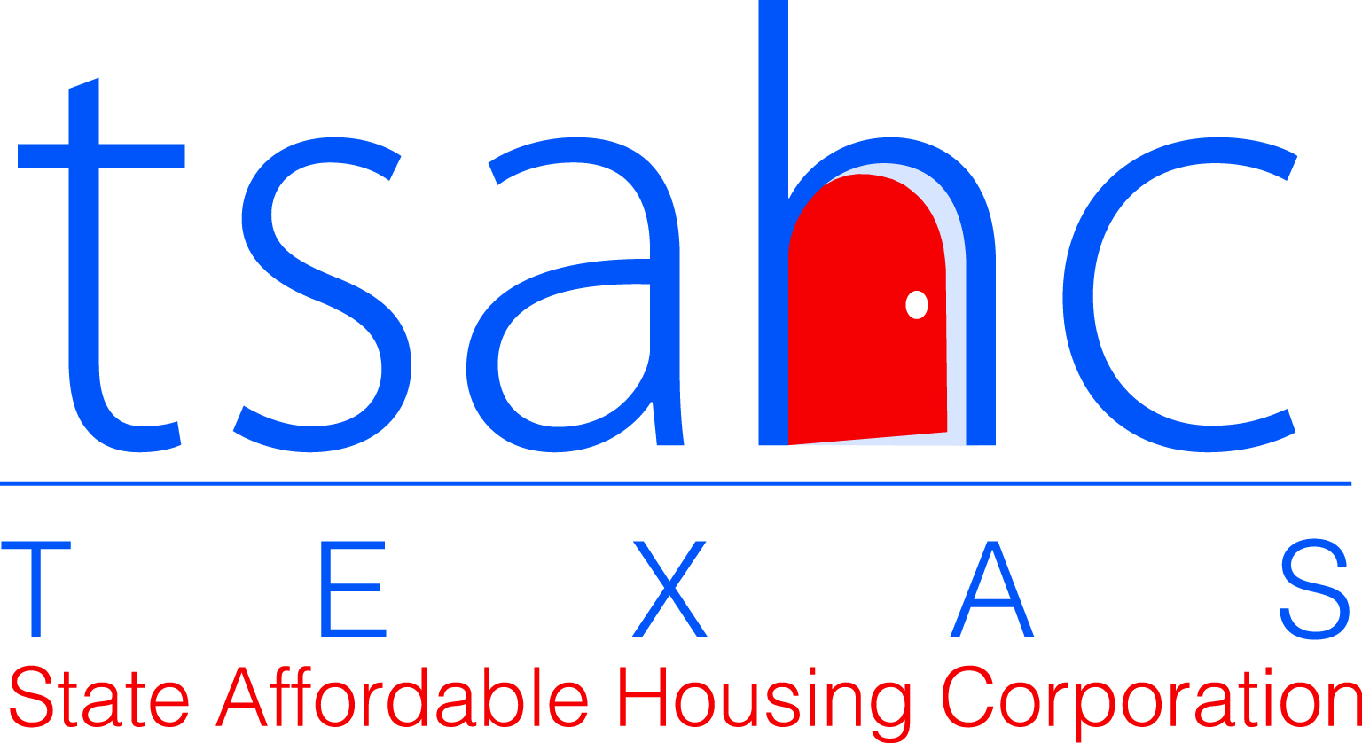

Notice to Residents of Assistance Available for Resolving Health and Safety Issues

To Resident:

The Texas State Affordable Housing Corporation (TSAHC) expects that the property managers of ___________________ will maintain the property and each individual rental unit in good working condition. Property management staff will inform you of the regular process you should use to report needed repairs, both emergencies and non-emergencies.

If you have notified property management staff about a maintenance issue that creates an unsafe, unhealthy, or uninhabitable environment, and you have allowed a reasonable time for correction, but the issue remains unresolved, you may contact a representative from TSAHC’s Multifamily Compliance Department at 512-477-3555 or by email at rentdesk@tsahc.org. TSAHC should be contacted only for serious issues.

If there is an emergency in your apartment home you should contact 911 and management immediately.

Please acknowledge your receipt of this notice by signing and dating below:

_______________________________ ________________________
Resident Signature Date

